LAB – 1

Question 1
Create a NumPy array containing the integers from 1 to 20.
Perform the following operations:
1. Display the array.
2. Find the shape of the array.
3. Find the maximum and minimum values.
4. Calculate the mean and standard deviation.
5. Reshape the array into a 4 × 5 matrix.
6. Display the second row of the matrix.
7. Display the third column of the matrix.

import numpy as np
arr = np.arange(1, 21)
print("Array:")
print(arr)
print("\nShape of the array:")
print(arr.shape)
print("\nMaximum value:", arr.max())
print("Minimum value:", arr.min())
print("\nMean:", arr.mean())
print("Standard Deviation:", arr.std())
matrix = arr.reshape(4, 5)
print("\n4 × 5 Matrix:")
print(matrix)
print("\nSecond row:")
print(matrix[1])
print("\nThird column:")
print(matrix[:, 2])

OUTPUT:
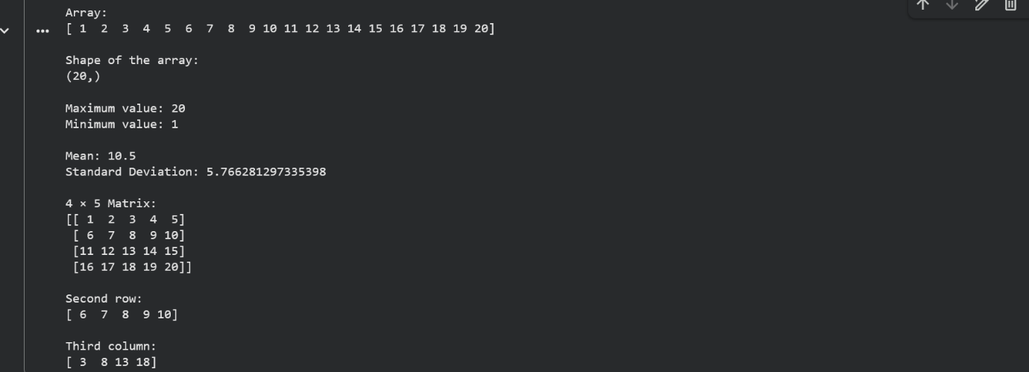

Question 2
Create two NumPy arrays:
A = [10, 20, 30, 40, 50]
B = [5, 10, 15, 20, 25]
Perform:
1. Addition of A and B.
2. Subtraction of B from A.
3. Element-wise multiplication.
4. Element-wise division.
5. Find the sum of all elements in A.

import numpy as np
A = np.array([10, 20, 30, 40, 50])
B = np.array([5, 10, 15, 20, 25])
print("Addition (A + B):")
print(A + B)

print("\nSubtraction (A - B):")
print(A - B)
print("\nElement-wise Multiplication (A * B):")
print(A * B)
print("\nElement-wise Division (A / B):")
print(A / B)
print("\nSum of all elements in A:")
print(A.sum())

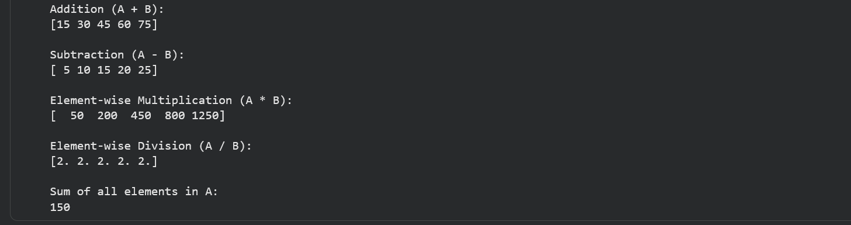

Question 3
Create a DataFrame using the following student data:
Roll No Name Marks
101 Ravi 85
102 Priya 92
103 Kiran 78
104 Anu 88
105 Sita 95
Perform the following operations:
1. Display the DataFrame.
2. Display the first three records.
3. Find the average marks.
4. Find the student with the highest marks.
5. Find the student with the lowest marks.
6. Add a new column called "Grade" using:
o A for Marks ≥ 90
o B for Marks between 80 and 89
o C for Marks < 80

import pandas as pd
data = {
"Roll No": [101, 102, 103, 104, 105],
"Name": ["Ravi", "Priya", "Kiran", "Anu", "Sita"],
"Marks": [85, 92, 78, 88, 95]
}
df = pd.DataFrame(data)
print("DataFrame:")
print(df)
print("\nFirst Three Records:")
print(df.head(3))
print("\nAverage Marks:", df["Marks"].mean())
print("\nStudent with Highest Marks:")
print(df.loc[df["Marks"].idxmax()])
print("\nStudent with Lowest Marks:")
print(df.loc[df["Marks"].idxmin()])
def grade(mark):
if mark >= 90:
return "A"
elif mark >= 80:
return "B"
else:
return "C"
df["Grade"] = df["Marks"].apply(grade)
print("\nDataFrame with Grade:")
print(df)

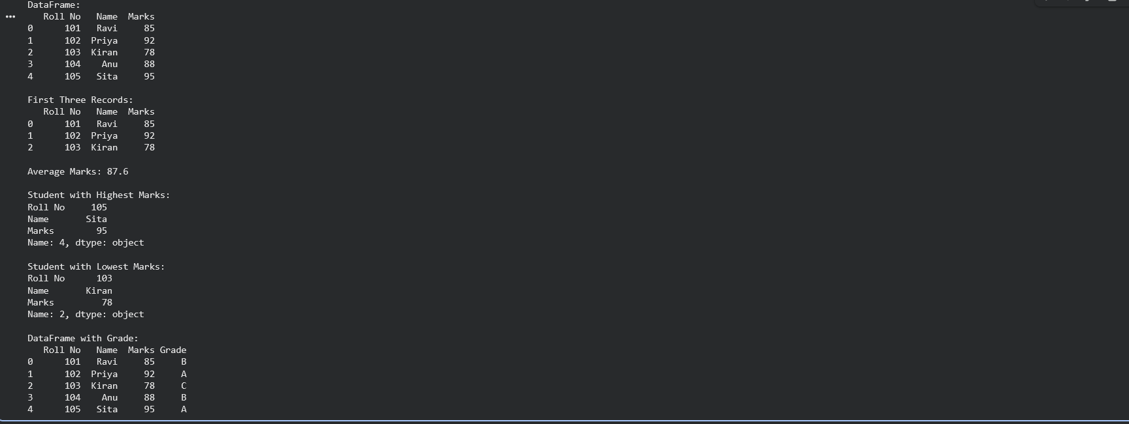

QUESTION 4
import pandas as pd
data = {
"Product": ["Laptop", "Mouse", "Keyboard", "Monitor"],
"Price": [50000, 500, 1200, 10000],
"Quantity": [10, 50, 30, 15]
}
df = pd.DataFrame(data)
df["Total Value"] = df["Price"] * df["Quantity"]
print("DataFrame:")
print(df)
print("\nProduct with Highest Total Value:")
print(df.loc[df["Total Value"].idxmax()])
overall_value = df["Total Value"].sum()
print("\nOverall Inventory Value:", overall_value)

OUTPUT:
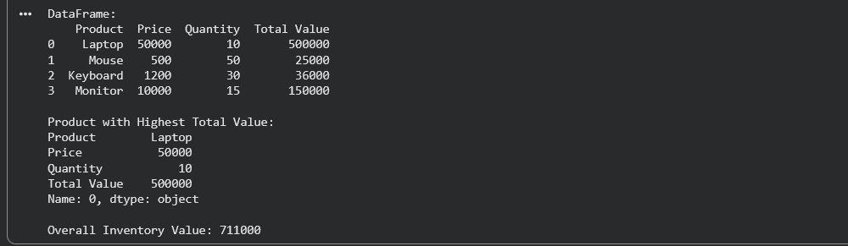

QUESTION 5
import pandas as pd
from sklearn.datasets import load_iris
iris = load_iris()
df = pd.DataFrame(iris.data, columns=iris.feature_names)
df["Species"] = iris.target
df["Species"] = df["Species"].map({
0: "setosa",
1: "versicolor",
2: "virginica"
})
print("Iris DataFrame:")
print(df)
print("\nFirst Five Records:")
print(df.head())
print("\nNumber of Rows and Columns:")
print(df.shape)
print("\nColumn Names:")
print(df.columns)
print("\nMissing Values:")
print(df.isnull().sum())
print("\nSummary Statistics:")
print(df.describe())
print("\nNumber of Samples in Each Class:")
print(df["Species"].value_counts())

